Explore Graph

This Graph is an example to test the ideas of exploring the path.

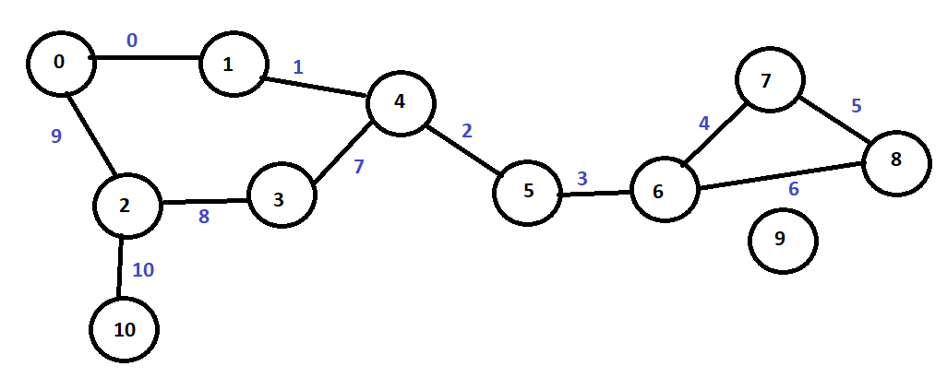

Figure 1The graph to search

**Test 1 start_v=0 end_v=9**

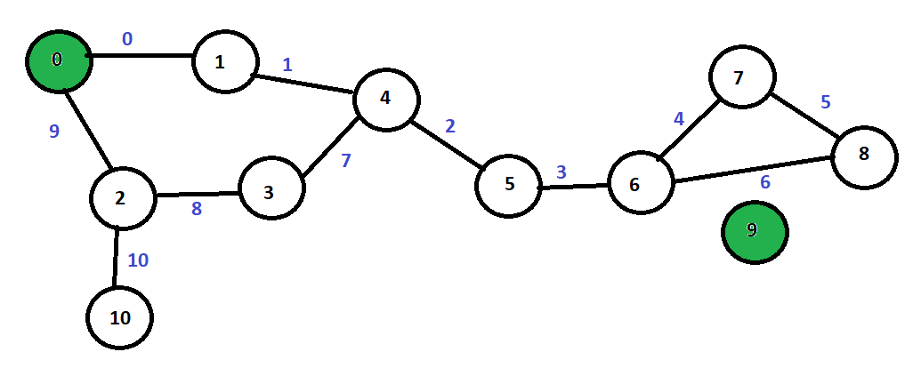

Figure 2Find path to Vertex with degree 0

Vertex 9 has a degree of 0 this means that there is no path so no need to explore anything.

**Test 2 start_v=0 end_v=10**

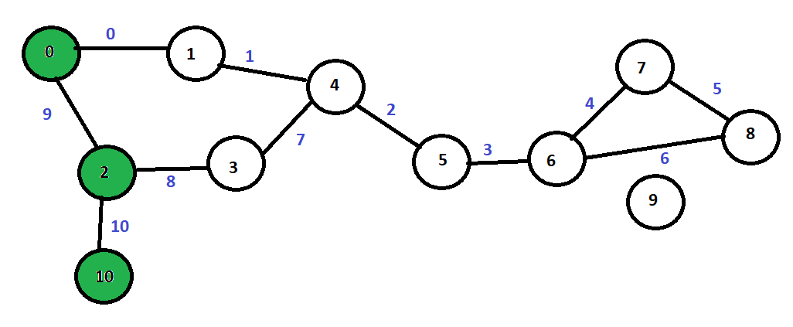

Figure 3Shortest Path to a Vertex

Short Path=V={0,2,10} E{9,10}

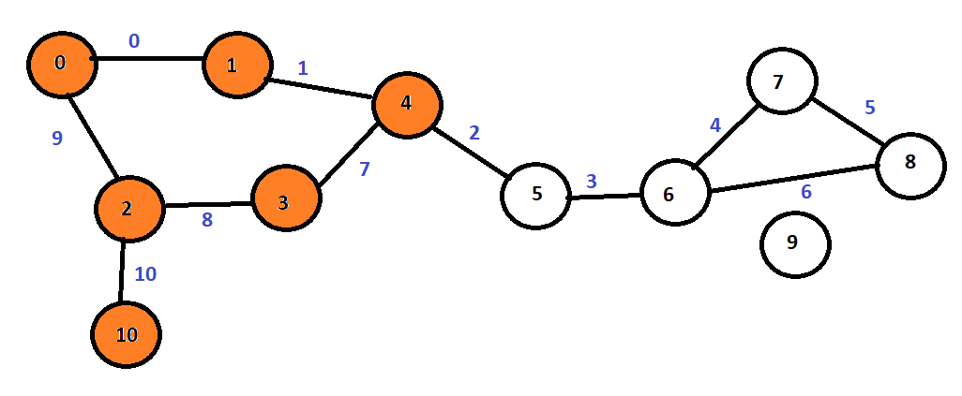

Figure 4Medium Path to Vertex

Medium Path=V={0,1,4,3,2,10} E={0,1,7,8,10}

Long Path=v={0,1,4,5,6,7,8,7,6,5,4,3,2,10} e={0,1,2,3,4,5,5,4,3,2,7,8,10}

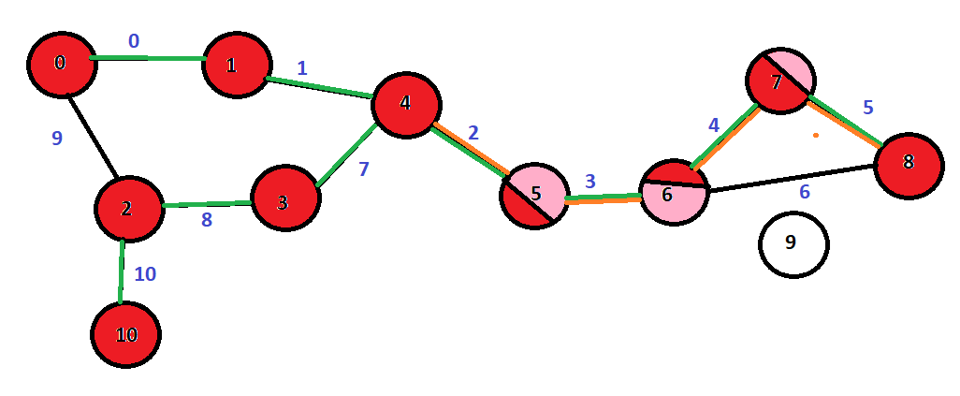

Figure 5 Longest Path to Vertex

Shortcuts

First don't cross bridge paths unless you must cross it.

In this example crossing the path is worst thing to do.

If you find a duplicate V then go back to the start_v=0 then find non duplicated vertices.

Check to level X both the start_v and end_v

In the above example if X = 3 then

the vertices 3 from 0 are in any direction are

Path 1 V={0,1,4} Path 2 V={0,2,10}

the vertices 3 from 10 are in any direction are

Path 1 V={10,2,3} Path 2 V={10,2,0}

Is there a relationship between Diameter/radios and the average path length? If there is we have to know the diameter and radius first. Maybe get diameter and radius when constructing the graph.

If a Vertex has a degree of 1 then finding a path to the vertex connected to it is to find a path to it.

In the case of V10 all paths go through V2.

**Test 3 start_v=5 end_v=1**

Longest Path V={5,6,7,8,8,7,6,5,4,3,2,10,10,2,0,1} E={3,4,5,5,4,3}

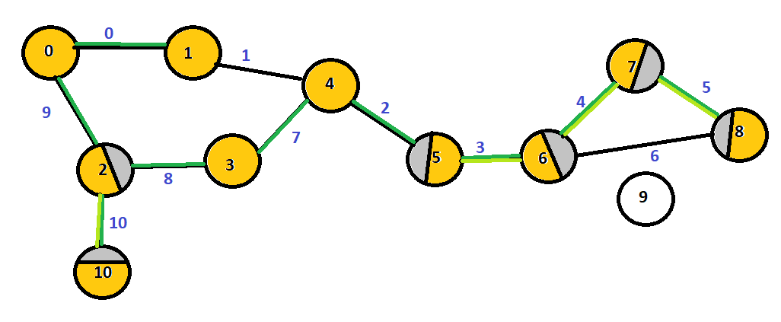

If you find a duplicate V then go back to start_v=5 then find non duplicated vertices IF YOU CAN.

V10 should not be visited as it has a degree of 1.

We cannot avoid bridges in this case because V5 is on a bridge.

When choosing a path choose the closest numerically to end_v when end_v=1 then from start_v=5 go to v=4 not v=6.

Medium Path V={5,4,3,2,0,1} E={2,7,8,9,0}

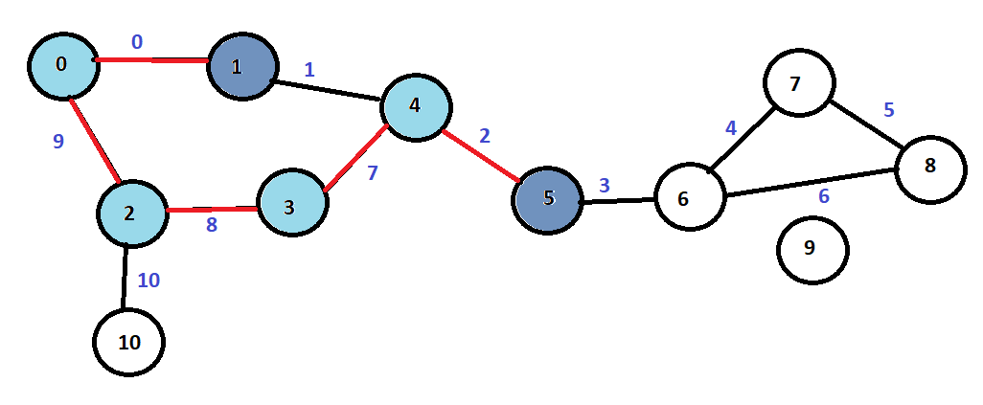

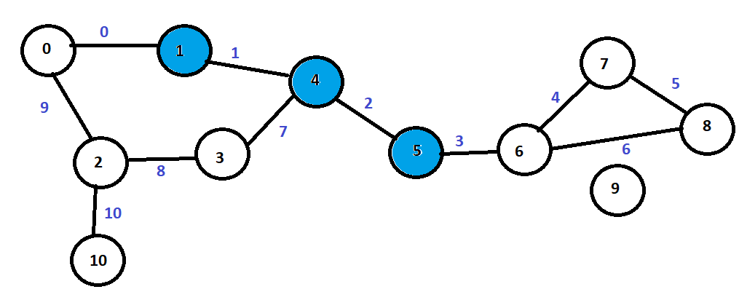

Shortest Path V={5,4,1} E={2,1}